**Group members:**

Maaz Habib(20pwcse1952)

Hamid Ur Rehman(20pwcse1969)

Danyal Khursheed(20pwcse1959)

**Section:** C



**Project:**

Music rhythm led flashlight circuit

**components:**

* Breadboard - x 1
* Electret Microphone - x 1
* Transistor - (BC547) x 9 NPN TYPE
* Resistor - (1M) x 1 (10k) x 2 (22Ω) x 8
* LED (Light Emitting Diode) - (Any Colors) x 8
* Ceramic Disc Capacitor - (100nF) x 1
* DC Switch - x 1
* Battery - (9v, with battery clipper) x 1
* Connecting Wires

**Functionality:**

**1.breadboard:**

A **breadboard**, is a construction base for prototyping of electronics. Originally the word referred to a literal bread board, a polished piece of wood used when slicing bread. In the 1970s the **solderless breadboard** (a.k.a. **plugboard**, a terminal array board) became available and nowadays the term "breadboard" is commonly used to refer to these.

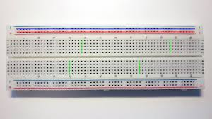

**2.Electret Microphone:**

An **electret microphone** is a type of electrostatic capacitor-based microphone, which eliminates the need for a polarizing power supply by using a permanently charged material.

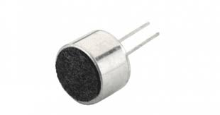

**3.Transistor:**

A transistor is a semiconductor device used to amplify or switch electrical signals and power. The transistor is one of the basic building blocks of modern electronics. It is composed of semiconductor material, usually with at least three terminals for connection to an electronic circuit.

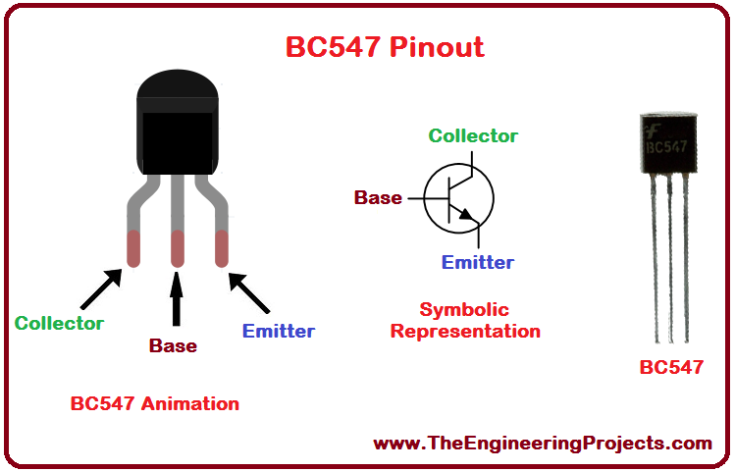

**4.Resistor:**

A resistor is an electrical component that limits or regulates the flow of electrical current in an electronic circuit. Resistors can also be used to provide a specific voltage for an active device such as a transistor.

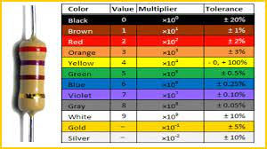

**5.LED (Light Emitting Diode):**

LED, in full light-emitting diode, in electronics, a semiconductor device that emits infrared or visible light when charged with an electric current.

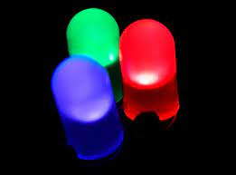

**6.Ceramic Disc Capacitor:**

A ceramic capacitor is a fixed-value capacitor where the ceramic material acts as the dielectric. It is constructed of two or more alternating layers.

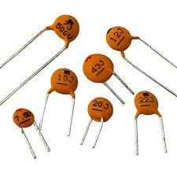

**7.DC Switch:**

direct current (dc) circuits are capable of carrying very different currents, as illustrated by the ratings on the switch in Figure 1. This is why it's so important for designers and engineers to understand how to pick the right switch for their product.

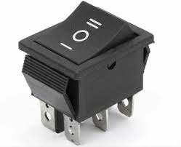

**8.Battery:**

An electric battery is a source of electric power consisting of one or more electrochemical cells with external connections for powering electrical devices. When a battery is supplying power, its positive terminal is the cathode and its negative terminal is the anode.

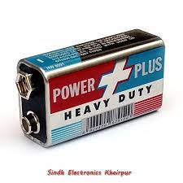

**9.Connecting Wires:**

Connecting wires allows an electrical current to travel from one point on a circuit to another because electricity needs a medium through which it can move.

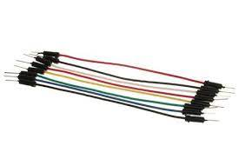

**Project figure:**

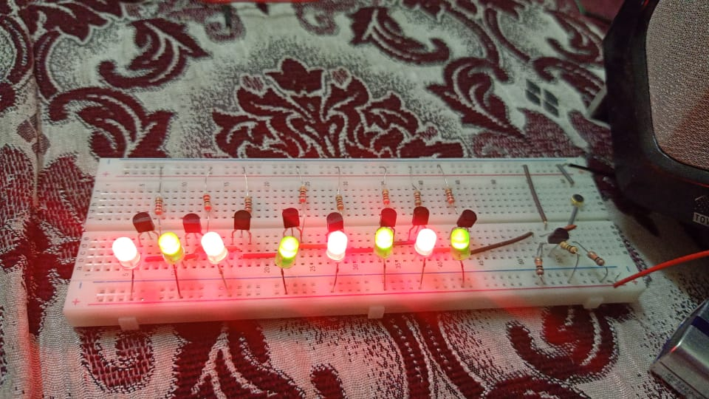

**Procedure:**

**We are creating the circuit of** Music rhythm led flashlight circuit:

1. First, we connect the transistor (one for receiving data from mic and all others for blinking purposes), on breadboard.
2. Then we connect the anode of 1 led to the positive rail and cathode of collector(transistor), following the procedure for the rest.
3. Then connect 22ohm resistor with emitter to ground and short bases of all transistors.
4. Connect the resistor 10k ohm with collector, connect emitter to ground, connect capacitor and 1M ohm resistor with base of transistor.
5. Connect the microphone with the capacitor with 10kohm resistor, the other leg of microphone is connected to ground.
6. Finally connect the battery and play some music.